vue-awesome-swiper的上一页下一页失效问题
对应vue-awesome-swiper版本2.67

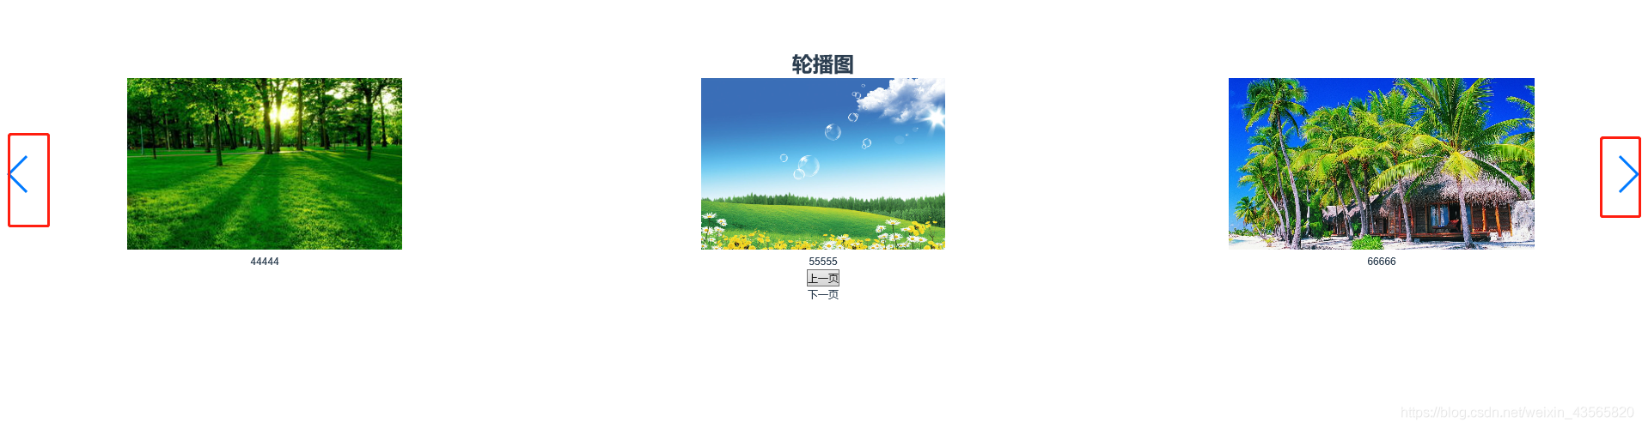
<template>
<div>
<h1>轮播图</h1>
<swiper :options="swiperOption" ref="mySwiper">
<swiper-slide v-for="(item, index) in list" :key="index">
<img @click="getImg(item)" :src="item.img" alt="">
<p>{{item.name}}</p>
</swiper-slide>
<div class="swiper-button-prev swiper-button-red" slot="button-prev"></div>
<div class="swiper-button-next swiper-button-blue" slot="button-next"></div>
</swiper>
<button @click="prev">上一页</button>
<div @click="next">下一页</div>
</div>
</template>

<script>
export default{
data () {
return {
list:[
{name: '11111', img: require('../../assets/img/1.jpg')},
{name: '22222', img: require('../../assets/img/2.jpg')},
{name: '33333', img: require('../../assets/img/3.jpg')},
{name: '44444', img: require('../../assets/img/4.jpg')},
{name: '55555', img: require('../../assets/img/5.jpg')},
{name: '66666', img: require('../../assets/img/6.jpg')},
{name: '77777', img: require('../../assets/img/7.jpg')},
{name: '88888', img: require('../../assets/img/8.jpg')},
{name: '99999', img: require('../../assets/img/9.jpg')},
{name: '10100', img: require('../../assets/img/10.jpg')},
] ,
swiperOption: {
slidesPerView: 3,
spaceBetween: 30,
slidesPerGroup: 3,
loop: true,
loopFillGroupWithBlank: true,
pagination: {
el: '.swiper-pagination',
clickable: true
},
navigation: {
nextEl: '.swiper-button-next',
prevEl: '.swiper-button-prev'
}
}
}
},
computed: {
swiper() {
return this.$refs.mySwiper.swiper
}
},

methods: {
getImg(item) {
console.log(item,'iiiii');

},
prev() {
this.swiper.slidePrev();
},
next() {
this.swiper.slideNext()
}
},

}
</script>
安装了2.6.7版本的发现上一页下一页使用不了,点击没有效果,这时有两个办法:
1.重新安装3.1.3版本的就能解决问题
2.使用 this.swiper来调用上一页下一页的方法,这样也方便了其他操作了

